70. Creating editable template in AEM.

**Steps to create editable template.**

1. To create dynamic/editable template, go to the Tools -> General -> configuration browser.

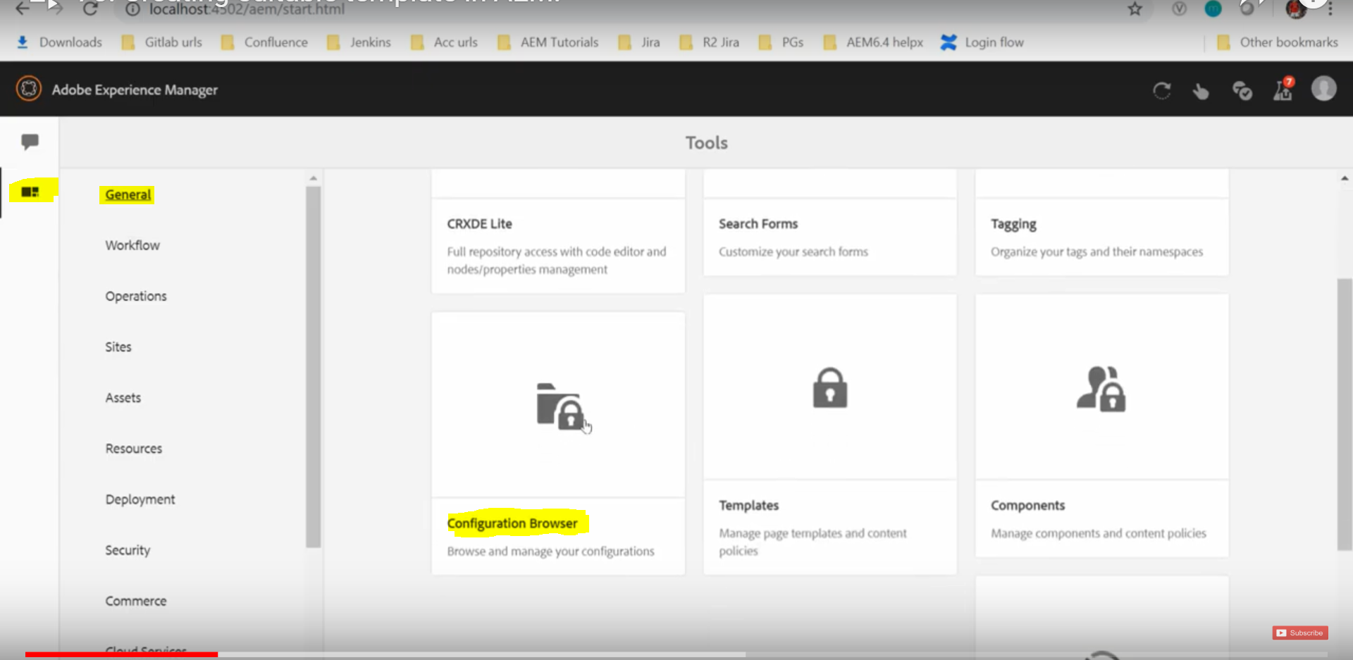

1. Click on create and give the title AEM-Tutorial and click on ok.

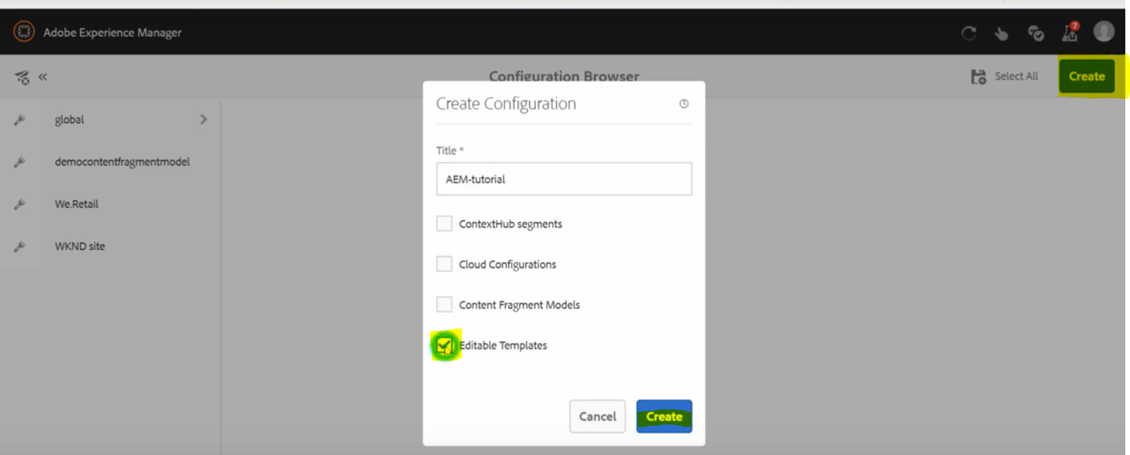

1. It will create a folder in template console (tool-general-template).

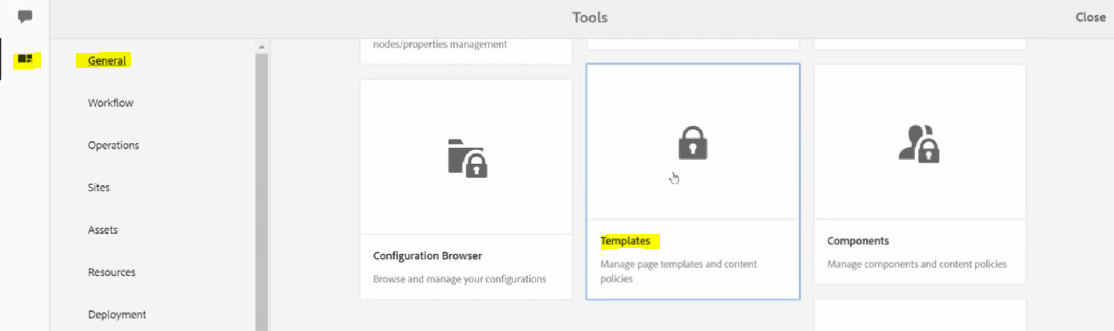

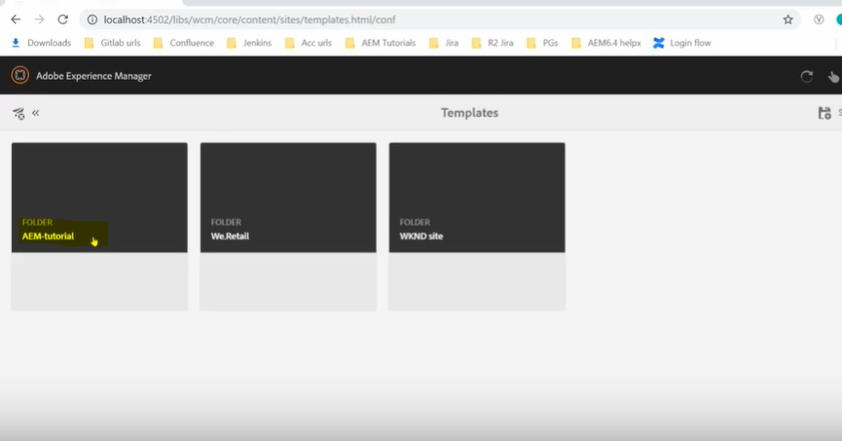

And it will also create a basic template structure in the conf folder.

Go to crx/de and open conf folder you will find the AEM-Tutorial folder there with the basic structure having below pages.

template: It consists of the template created by the template authors.

policies: It defines which components are allowed within the layout container.

template-types: This is a base template on basis of which template authors creates all of its template.

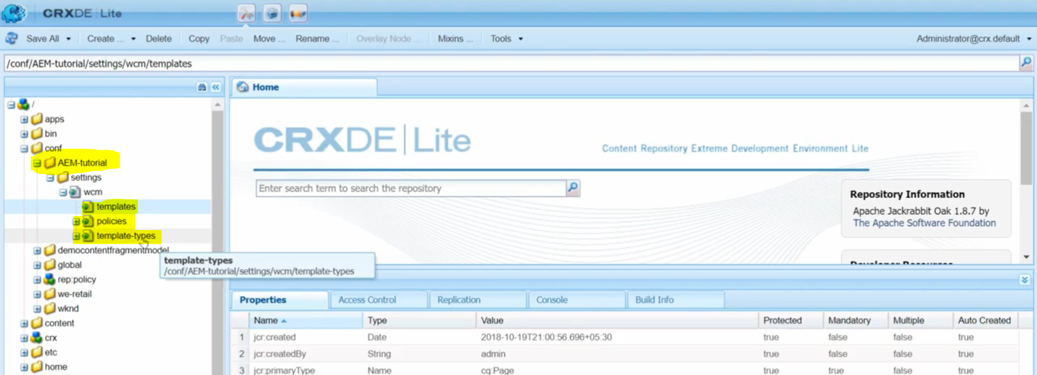

**How to create editable template?**

**Steps involved:**

1. Go to Tools -> General -> Templates

Click on create and select the default HTML template (base template type) to create the editable template.

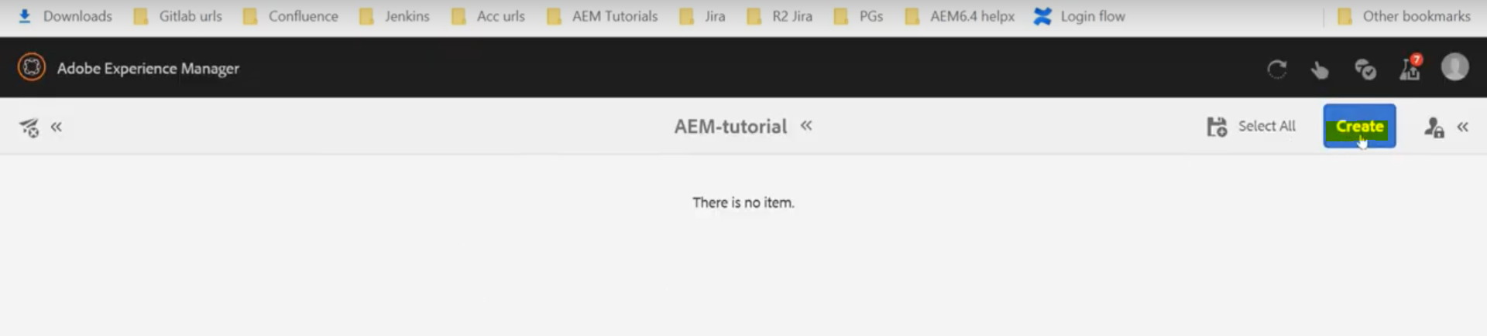

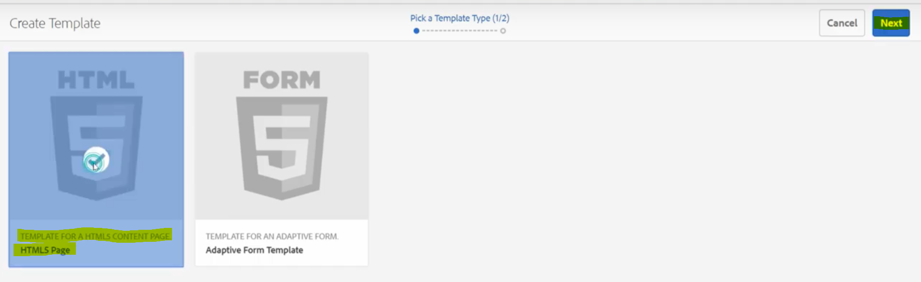

1. Provide required details to create the template (title & description) and click on create.

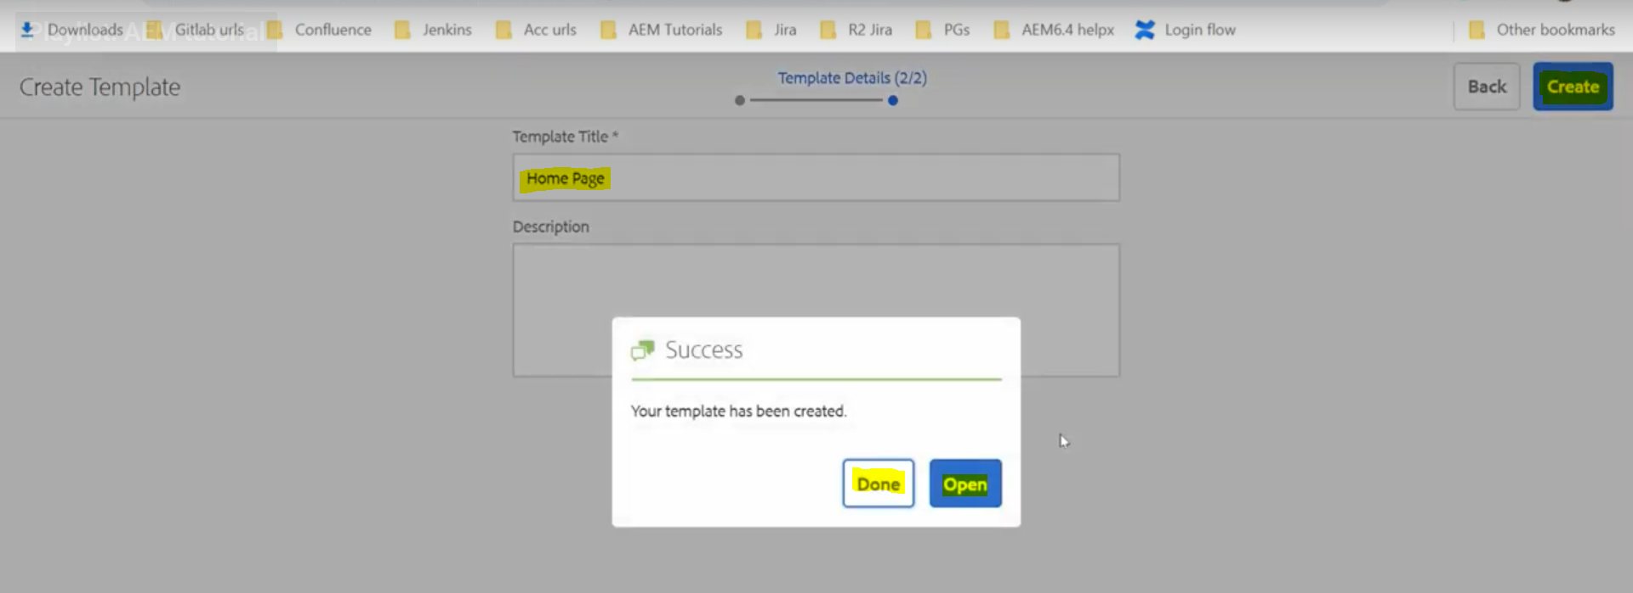

Now we can see the entry under conf/AEM-tutorial/settings/wcm/templates

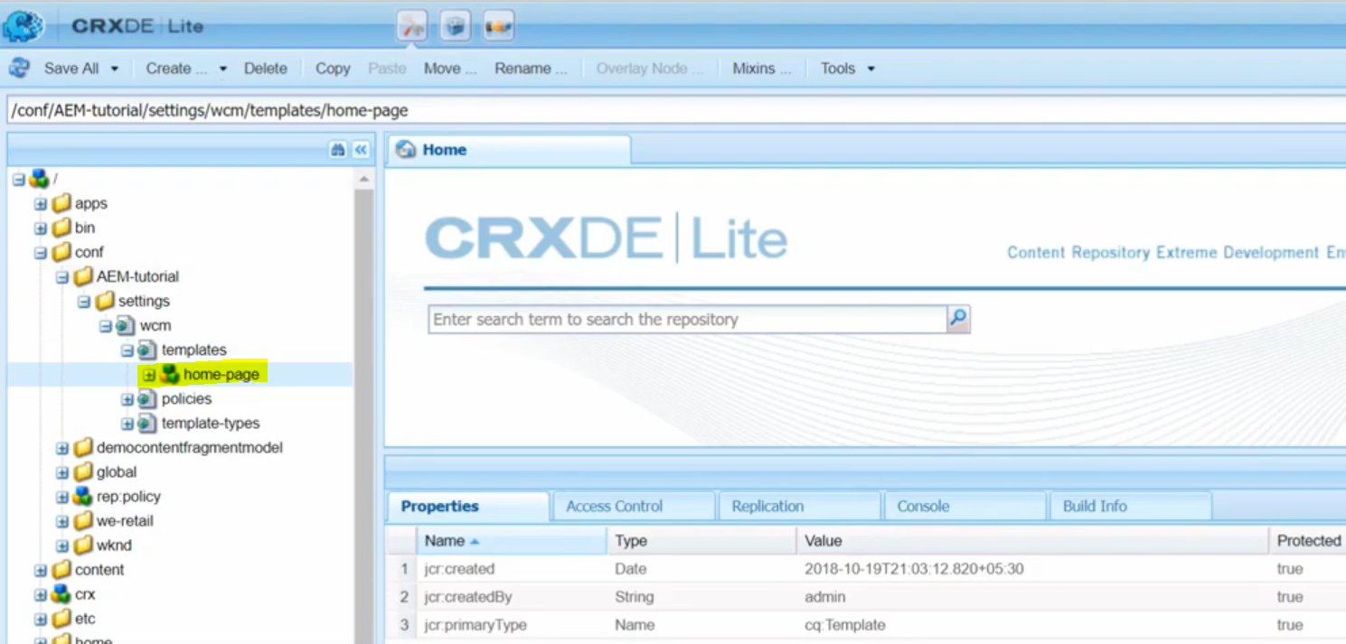

To edit the template, select the template created and click on edit and the template is ready to edit.

